|  |
| --- |
| Underwater Video Recording System |
| Dredge Mounted Camera v1 |

|  |
| --- |
| Arthur Bondar  *Electronics Technologist*  *February 24, 2020* |

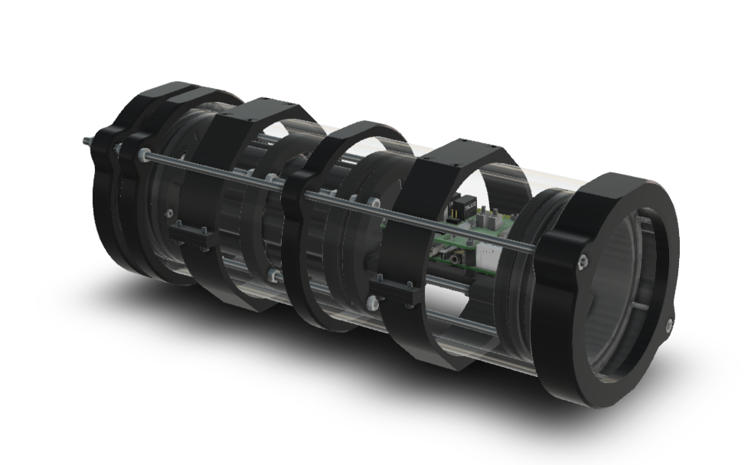

Contents

Overview 2

Mounting 3

Aluminum Housing Assembly 4

Acrylic Housing Assembly 5

Electronic Components 6

Battery 7

Deployment 9

Camera Settings 11

Video Output 13

Storage Requirements 13

Run Time 14

# Overview

Dredge Mounted Camera is developed to aid scallop fisheries with industry research and regulation. The unit is mounted on a scallop dredge and records continuously throughout the fishing trip. The system incorporates a large battery bank which allows for steady operation with minimal input from the user. The memory storage device can be swapped at any point during deployment extending the run time.

Specifications

|  |  |
| --- | --- |
| Video | HD camera 8MP (1920x1080p @30fps) |
| Run Time | 100hr – 4days |
| Dept Rating | Acrylic Housing – 100m (328ft)  Aluminum Housing – 400m (1312ft) |
| Memory | 256GB USB3.0 flash drive |
| Battery Pack | 266Wh 14.8V 18Ah Lithium-ion |
| Charger | 20A,10A Fast/Balance charging  1-2hr charge time |
| Dimension | Housing O.D. – 114.3mm (4.5”)  Length – 340mm (13.4”) |
| Weight | Acrylic Assembly – 6.4 lb (2.9 kg)  Aluminum Assembly – 6.8 lb (3.1 kg) |

Mounting  
The unit has two clamps with M4 threaded holes dedicated to mounting (x4 each clamp). The clamp consists of two brackets connected with via M3 hex screws.

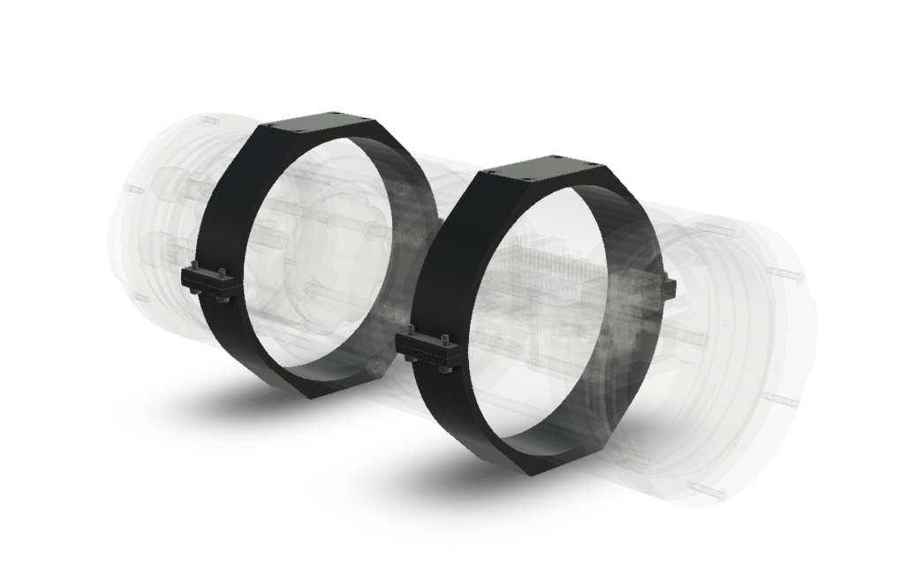

Mounting holes are M4x0.7 with a 5.5mm depth. To secure the unit on a platform, different length M4 bolts and lock washers are used for different material thickness - 8, 12, 14 and 16mm length.

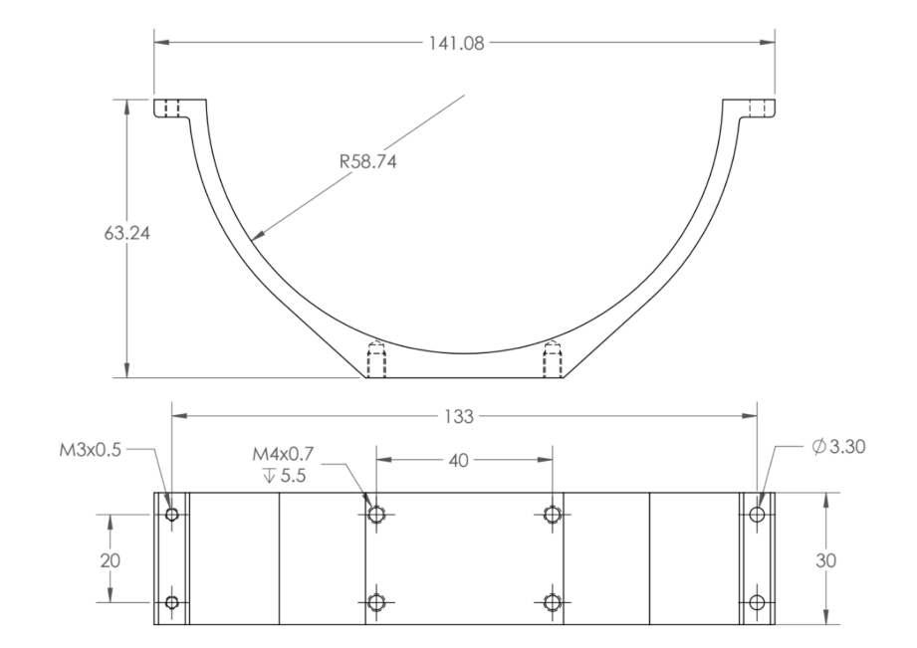

*Drawing Dimensions in millimetres*

# Aluminum Housing Assembly

The unit has two housing configurations – acrylic and aluminum. The acrylic enclosure is easier to open and close, with better support for internal components. Aluminum offers better thermal performance and is more rugged. Both enclosures are 114.3mm outer diameter and 320mm in length with end caps.

The aluminum enclosure is rated up to 400m (1312ft). The assembly includes the following:

* Aluminum Enclosure
* x2 Aluminum Flanges with O-rings
* Aluminum Endcap with 5 holes
* Clear Acrylic end cap
* x2 Mounting Clamps

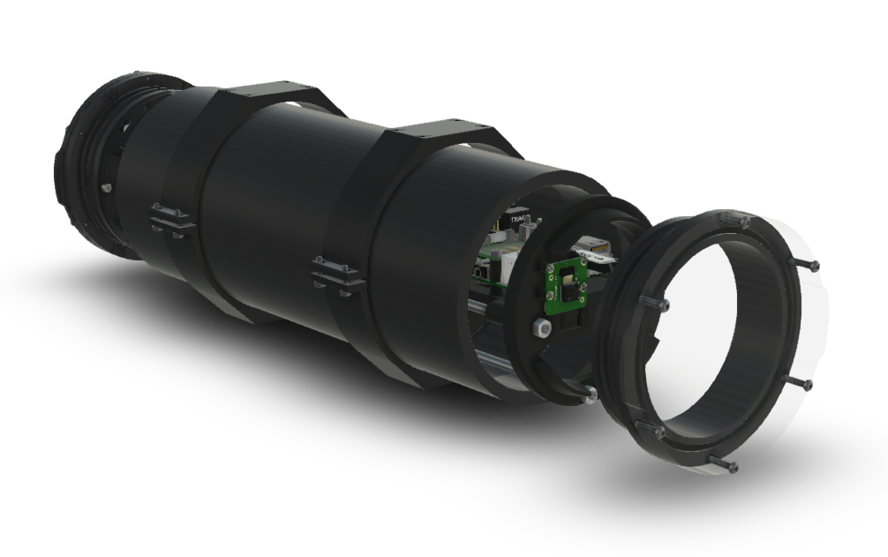

The back-end cap has a vent plug that allows air to escape when the enclosure is opened and closed. The vent cap should be kept open when the inner assembly is inserted or removed.

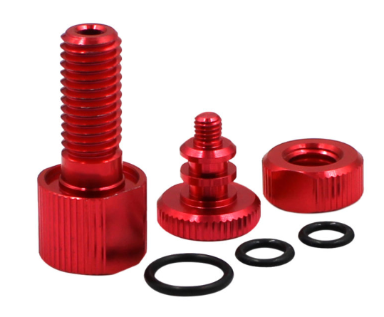

Note: In thermally intensive application, such as powering motors or lights, air pressure can build-up inside the enclosure. For this reason, the aluminum housing is machined to a smaller clearance with the flanges, making it difficult to open and close. The notches around the flanged are used to pry the unit open using a flat screwdriver.

# Acrylic Housing Assembly

The acrylic housing tube diameter is slightly greater than that of aluminum, thus, the enclosure is easier to open and close. Unlike aluminum, this housing is a simple cylinder extrusion, which offers better support for electronic components by limiting the movement inside the tube.

The acrylic assembly is identical to the aluminum, with the addition of plastic flange clamps. A few plastic parts are made as a reassurance that the flanges stay in place with thermal expansion and vibrations. The plastic end caps also provide moderate protection for the acrylic from chipping.

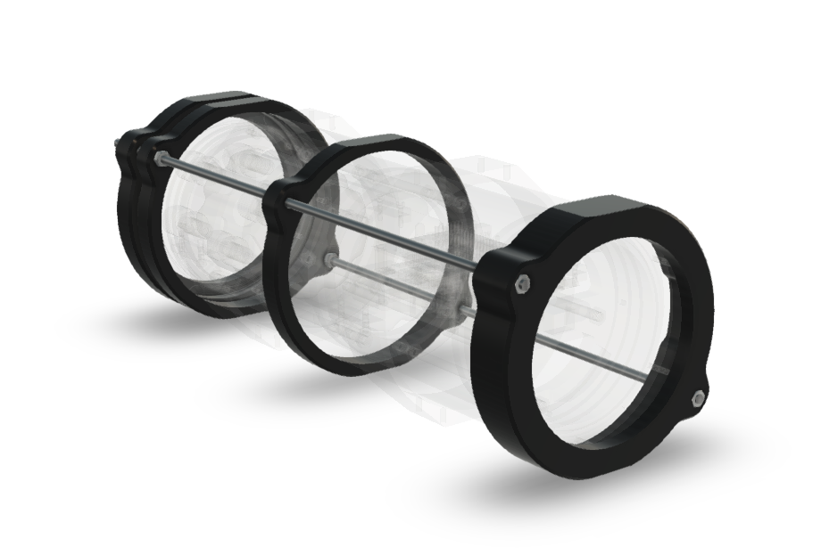

Two M4 nuts hold the end cap in place at the back of the unit. The nuts do not require high torque and can be tightened using regular plyers. Threaded rods are designed at an angle to provide clearance to assemble the mounting clamps.

# Electronic Components

The electronics components are modular and can be easily substituted with a replacement or an upgrade.

The main components of the include the following:

* Blue Robotics 266Wh battery pack.
* Raspberry Pi 3 B single-board computer.
* Stacking circuit board.
* USB 3.0 Memory device.
* Raspberry Pi Camera V2.

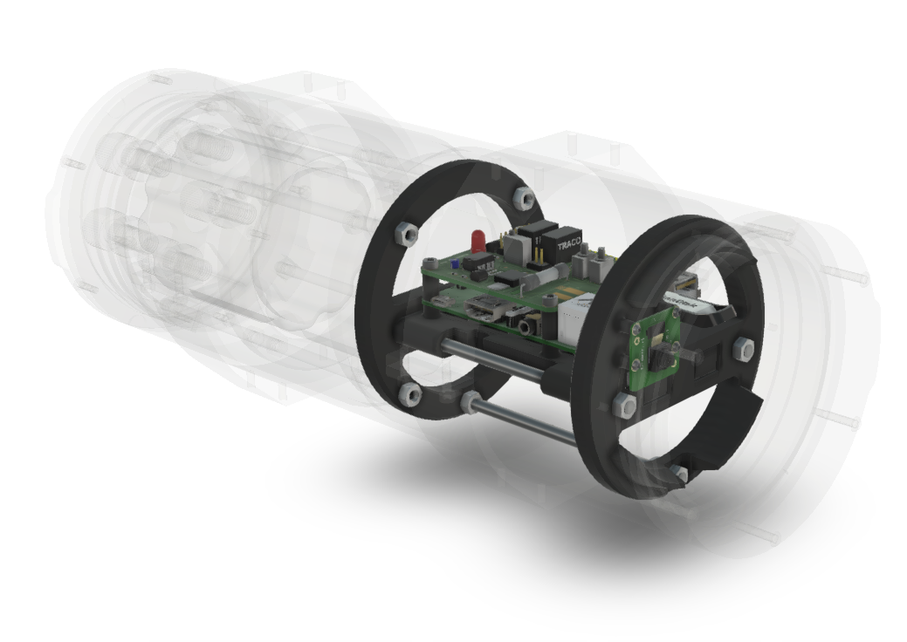

The single-board computer is responsible for video processing and storage, while the stacking circuit board is providing power, as well as, short circuit and battery voltage protection. The stacking board connects to the battery via an XT90 power connector that comes with the battery. The board has LED indicators and a push-button for user input.

# Battery

The battery pack is a high capacity Lithium-Ion battery from Blue Robotics. Internally, the pack is wired in a 4S cell configuration, providing an operating voltage of 12V to 16.8V. The battery pack has 3 connectors:

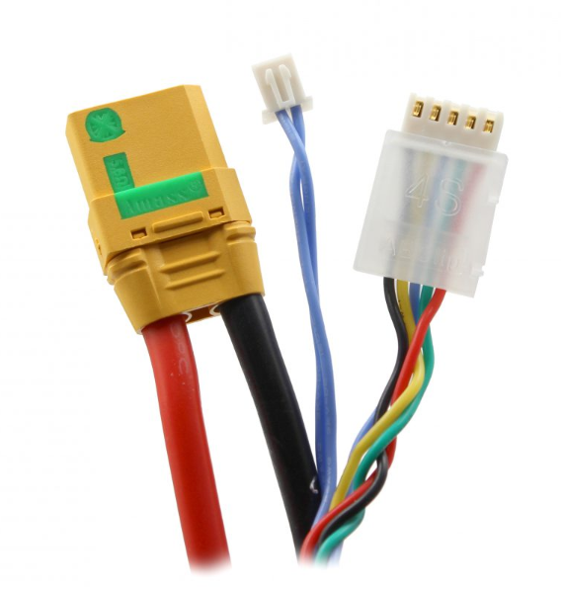

* XT90 Power connector *(left)*
* 2-pin JST Thermistor *(middle)*
* 5-pin JST Balance charging port *(right)*

The battery bank connects to the camera via the XT90 connector. The balancing connector is used when charging or testing the cell condition. A small battery tester (capacity controller) can be used to read battery percentage, as well as other cell information.

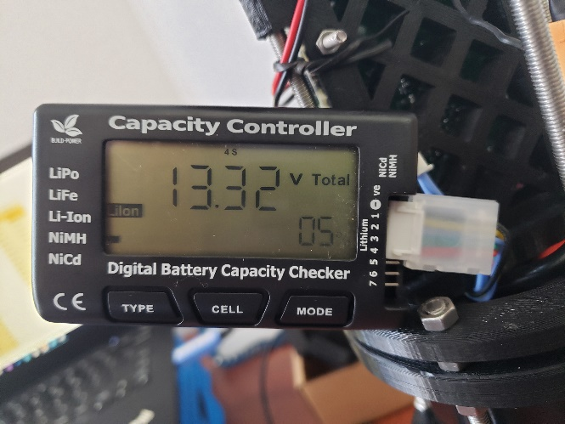

Connect the 5-pin balancing connector to the numbered ports on the side of the unit, starting with the **-Ve** pin. Use the TYPE bottom to scroll through the chemistry types and select **Li-Ion**. The tester will show the state of charge in percentage, pack voltage and individual cell voltages. If nothing appears on the screen, check the connector orientation. The black wire of the balance connector should align with the negative mark on the tester.Charging

The unit includes a high-power battery charger from Blue Robotics. The charger can deliver up to 20A in Fast charging, and 10A in Balance charging mode. Charging current is selectable and the charge time will vary accordingly. Using the recommended 10A current limit, the typical charge time is 2 hours.

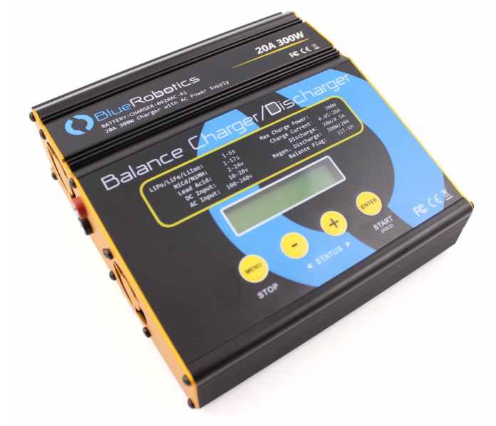

Charging instructions:

* Connect the red and black leads of the XT90 adapter to the **OUTPUT** terminal on the side panel of the charger.
* Connect the battery to the charger via the XT90 connectors.
* Connect the 5-pin Balance connector to the ‘4-Cell’ 5-pin socket located on the side panel of the charger.
* Navigate the Program select screen using the Menu key and choose Lithium battery. Press enter to verify the selection.
* Use the Status buttons ( - and + ) to select BALANCE CHG for balance charging.
* Press Enter to select the appropriate Lithium battery chemistry type - **Li Io.**
* Press Enter once again to select the charging current – up to 10A.
* Press and hold the START button to start charging.

The charger has thermal protection and a timeout feature. If charging timeout was reached before ahead of time, simply reset the charging cycle. More information is available in the datasheet provided with the battery.

# Deployment

The camera system is designed to operate for two consecutive fishing trips. The battery bank allows for a 4-day continuous recording. However, the 256GB memory drive can typically store 2 days worth of footage. Recording can be paused to swap the drive without the need to re-charge the battery.

The unit’s logic board has a push button, a power switch and three LED indicators.

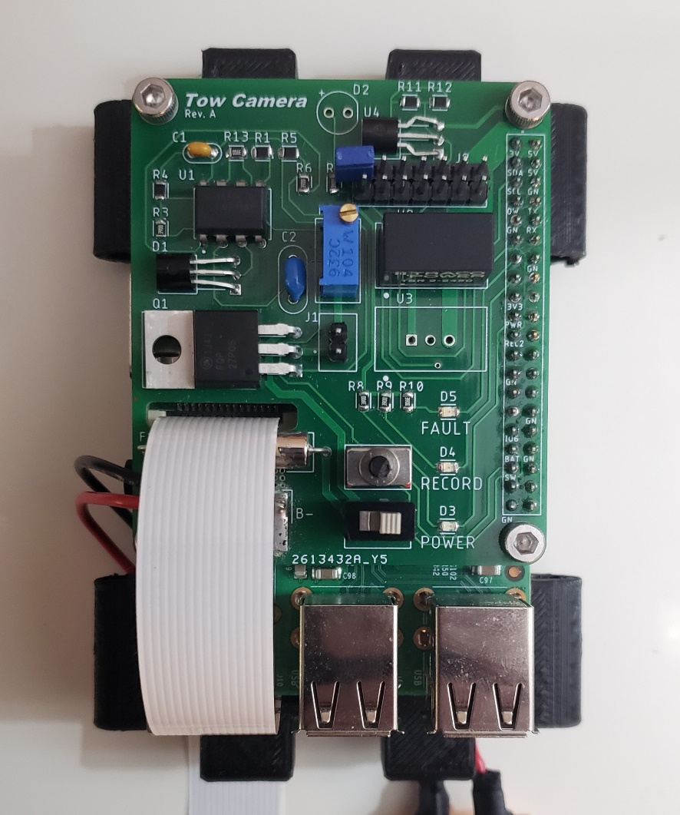

**Push button**

**Power switch**

**Fault LED**

**Power LED**

**Recording LED LED**

* Switch – manual power switch.
* Push-button – short press – start/stop recording, long press - shutdown.
* **Yellow** Fault LED – out of disk space or an internal error.
* **Green** Power LED – normal operation.
* **Red** Recording LED – recording in progress.

Deployment sequence:

|  |  |  |  |  |  |  |  |  |
| --- | --- | --- | --- | --- | --- | --- | --- | --- |
| Power up | -> | Button press to  start recording | -> | Recording | -> | Button press to  end recording  OR  Battery low  OR  Out of disk space | -> | Shutdown  OR  Standby for disk swapping |

1. Edit the setup file using notepad. Set the required video parameters and the date-time of the deployment if time tracking required. Insert the USB drive in one of the USB ports.
2. Connect the battery via the XT90 power connector.
3. Switch the power and allow for one minute for the system to boot. A green LED will blink 10 times indicated start-up.
4. The unit will perform a disk check. If no drive was found, step 1 skipped, a yellow light will flash. Insert the drive and press the push-button.
5. A green light will blink, indicating a standby before recording. Press the push button once again to start recording. A red recording light will appear shortly after.
6. Video recording will continue until the memory device is full, the battery is depleted, or the push button was pressed. The system will automatically shut down when the battery is low. When the disk runs out of memory, a yellow fault light will flash, and the drive can be swapped followed by steps 4 and 5.
7. Upon the end of a deployment, turn off the unit by pressing and holding the push-button for 5 seconds. Note: always properly shut down the unit before removing the USB storage disk.
8. Switch off the power to prevent further battery depletion.

# Camera Settings

The unit has a simple interface that is implemented via a text file located on the USB drive - **setup.txt**. This file contains various commands and parameters for the video recording. The settings file is located at the root of the USB drive, and can be edited using notepad.

Each line that starts with # is considered a comment. Other entries follow a key-value pair format separated by = sign. The following table summaries each parameter and its function:

|  |  |  |
| --- | --- | --- |
| **Parameter** | **Value** | **Description** |
| section | 0 – inf (in minutes) | The recording is split into multiple files to prevent video corruption then faults occur. This parameter specifies the section length in minutes. 0 will produce a single file (default 60). |
| use date-time | on / off | When date-time turned on, the video image will show a timestamp at the top. |
| set date-time | DD-MM-YYYY **T** HH:MM:SS | The unit does not keep track of time after power off. When the timestamp is needed, the time must be manually written to the setup file before **each** deployment. Set time for 1 minute ahead to allow for the system to boot. |
| resolution | [width]x[length] | Various resolution settings can be used by the video encoder. A list of options and framerate is found in the setup file. Note: 1920x1080 resolution provides a narrow field of view, which results in less area captured in the footage. The default resolution of 1640x1232 provides adequate quality. |
| framerate | 1 – 90 | A higher frame rate creates a smooth motion of objects in the video. However, higher rates result in larger video files. The typical framerate is 25 fps. |
| rotation | 0-359 | Camera sensor rotation. If the unit is mounted at an angle, change this parameter to adjust the recording. |
| bitrate | 0-25 | Bitrate defines the maximum size of the video stream. Higher values will produce higher quality footage, which requires more space. This value is adjusted to preserve disk space. A typical value is 10-15, depending on storage and the length of deployment. |
|  | Developer settings | Settings that are used to troubleshoot and recover information from the unit. At the end of each deployment, a log file is generated on the disk - log.txt. |

Software update

The software of the unit can be updated via the USB drive. Copy the new software file - **software.bin,** to the root of the drive. The new software will be installed on the first start-up, and the file can be removed from the disk.

Memory Device Replacement

1. Pause the recording by pressing the push-button.
2. Wait for recording to stop and a blinking yellow light to appear.
3. Remove the old drive and insert a new one.
4. Press the push-button to mount the new drive. A blinking green light will appear.
5. Press the button once again to start recording.

If the unit ran out of disk space (yellow blinking light), skip to step 3.

# Video Output

The camera uses the H.264 video format. It is a widely popular format used by security cameras, mobile phones, streaming services and others. The output contains a raw video stream (no audio) and requires a container format to be watchable on a typical media player - MP4, MOV, F4V etc. Conversion from h.264 to MP4 can be done by most media editing software packages. Typically, the editor will read the video parameters from the .h264 file itself, however, resolution, frame and bitrate from the setup file can be set manually. An example of a video converter that can encode H.264 to MP4 is **WinX HD Deluxe**.

Video files have the following convention:

[file index]_[date]_[time]   
XXX_YYYY-MM-DD_HH-MM.h264

Note: when timestamp is not used in the setup file, the video date-time will be incorrect.

# Storage Requirements

The system can support USB 2.0, 3.0 and 3.1 flash drives. The video stream is relatively slow and does not require USB3.0 speed. However, higher speeds become useful when copying the video to a PC. It is recommended to use a drive with at least 128GB of memory available.

Before using a new memory device, format the drive using the **exFAT** file format. In Windows, right-click on the drive and select format. Choose the exFAT file system, a default allocation unit size, and perform a quick format.

The h264 video stream is compressed by only encoding the difference between each frame. Thus, more motion and sunlight captured by the lens will result in a larger video file. Recording rate varies in time, yet the maximum allowable rate can be limited. The maximum recording rate in Mega Bits per second (Mbps) is controlled by the **bitrate** variable in the setup file.

The following formula is used to calculate files sizes and spec the storage requirements:

|  |  |  |  |
| --- | --- | --- | --- |
| **Bitrate** | **MB / s** | **GB / hr** | **GB / day** |
| 4 Mbps | 0.5 MB/s | 1.8 GB | 43.2 GB |
| 6 Mbps | 0.75 MB/s | 2.7 GB | 64.8 GB |
| 8 Mbps | 1 MB/s | 3.6 GB | 86.4 GB |
| 10 Mbps | 1.25 MB/s | 4.5 GB | 108 GB |
| 12 Mbps | 1.5 MB/s | 5.4 GB | 129.6 GB |
| 14 Mbps | 1.75 MB/s | 6.3 GB | 151.2 GB |
| 16 Mbps | 2.0 MB/s | 7.2 GB | 172.8 GB |
| 18 Mbps | 2.25 MB/s | 8.1 GB | 194.4 GB |
| 20 Mbps | 2.5 MB/s | 9.0 GB | 216 GB |

Higher frame rates and resolutions generally require higher bitrate. Overall, there is a trade-off between more frames and the quality for a given rate. The default bitrate for the system is 10Mbps, which results in a 2-day continuous recording on a 256GB flash drive.

# Run Time

The power consumption varies depending on the video load and the USB power requirements. The typical average power consumption is 2.5W. Using the battery capacity of 266Wh, the run time can be estimated by dividing the power consumption by the battery capacity. The capacity tester should be used to verify the state of charge when possible.

|  |  |  |
| --- | --- | --- |
| Typical power consumption | 2.5W | 266Wh/2.5W = 106.4 hr |
| Low power consumption | 2W | 266/2W = 133 hr |
| High power consumption | 3W | 266/3W = 88.6 hr |